### 

### Year 11 Mathematics Methods

# Test 2 2023

# Section 1: Calculator Free

Name: __________________

## Time Allocation: 25 Minutes Marks: ________ / 22

**Show all your working clearly.** *Your working should be in sufficient detail to allow your answers to be checked readily and for marks to be awarded for reasoning. Correct answers given without supporting reasoning may not be allocated full marks. Incorrect answers given without supporting reasoning cannot be allocated any marks.*

__________________________________________________________________________

1. The lines  and  meet at the point P which has coordinates (0, 4).
   1. Determine the equation of the line through P and parallel to the line with equation $3x+y=8$.
   2. Determine the equation of the line through P and perpendicular to the line with equation

$3x+y=8$.

**[1 + 2 = 3 marks]**

1. Find the equation of the line through points A(-2, 7) and B(-5, -2),

**[2 marks]**

1. What is the natural domain of the following functions?
   1. 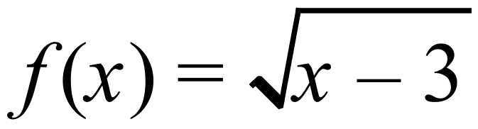

* 1. 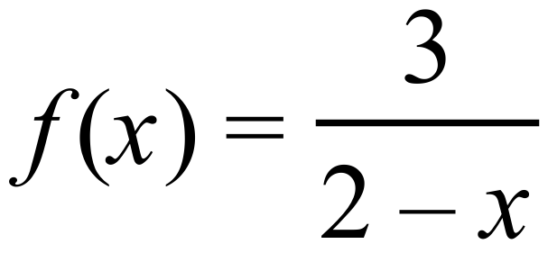

**[2 marks]**

1. Which of the following represent functions? (Circle the letter if it is a function)
2. 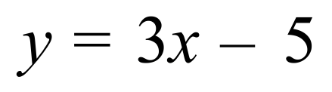 b) 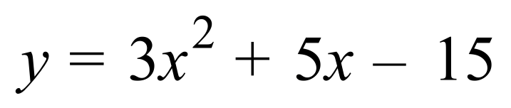

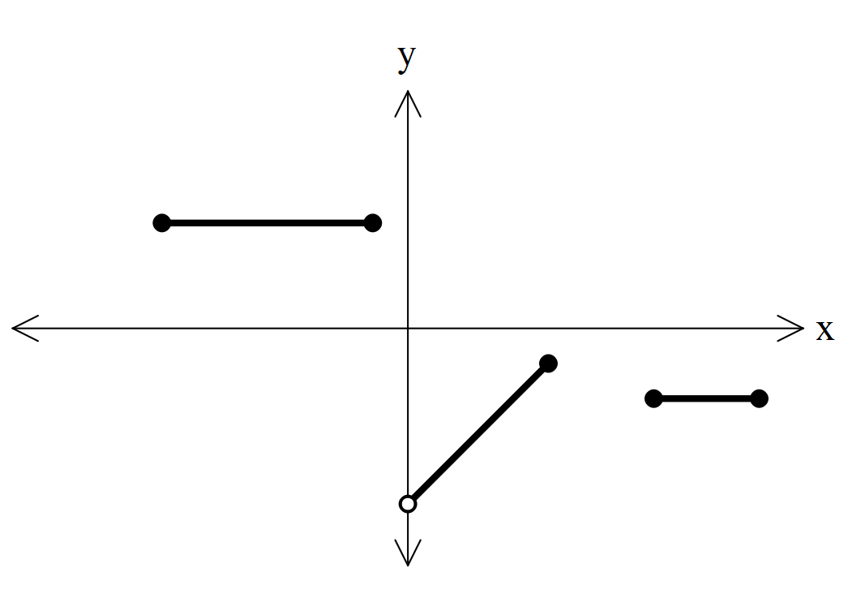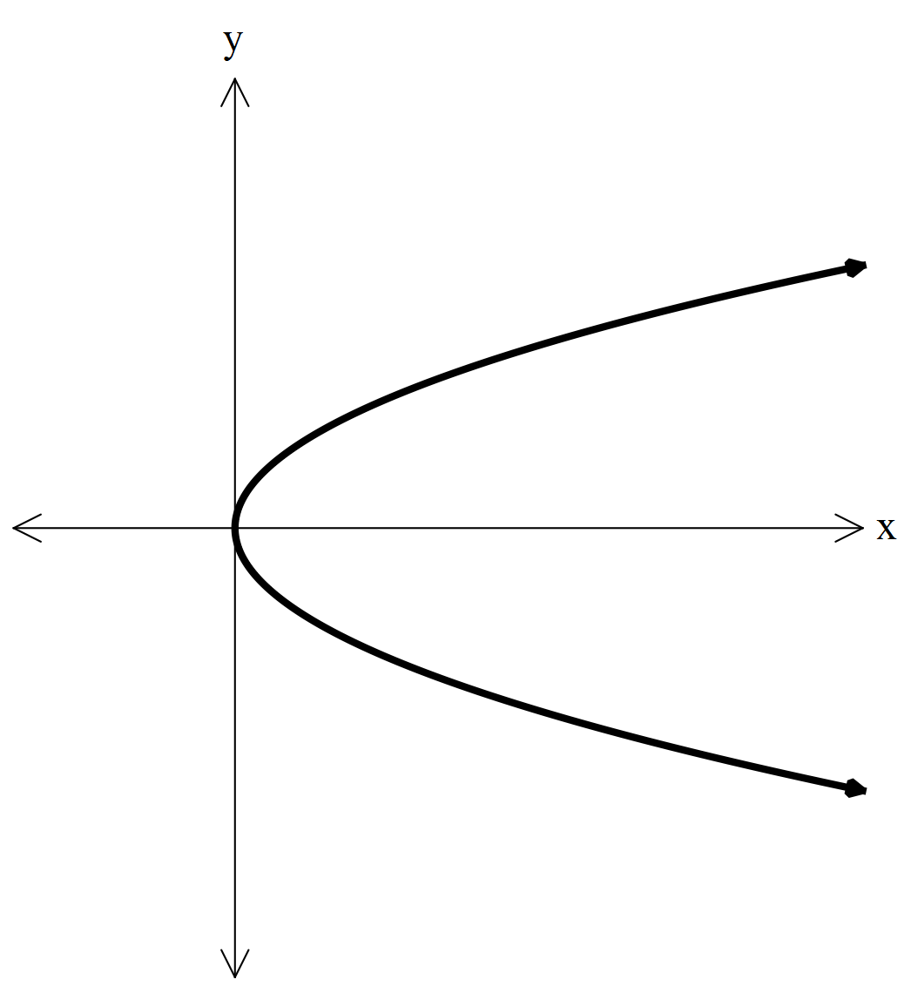c) d)

**[4 marks]**

1. What is the range of the function 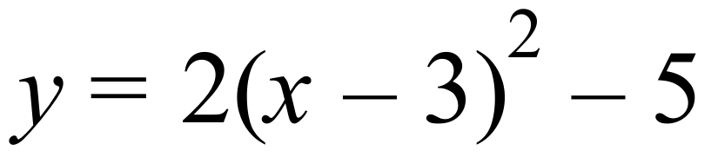 over the domain 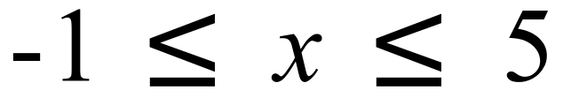 ?

**[2 marks]**

1. The expansion of ${\left(x+1\right)}^{11}$ is

$$x^{11}+11x^{10}+55x^{9}+165x^{8}+330x^{7}+462x^{6}+462x^{5}+330x^{4}+165x^{3}+55x^{2}+11x+1.$$

Determine the number of combinations of $7$ objects taken from a set of $11$ distinct objects.

**[2 marks]**

7)) Without the use of calculator, find:

a) ${}_{}^{4}{C_{0}^{}}+{}_{}^{4}{C_{1}^{}+{}_{}^{4}{C_{2}^{}}+{}_{}^{4}{C_{3}^{}}}+{}_{}^{4}{C_{4}^{}}$

b) $\left({9 \atop 4}\right) ×4!$

c) A 3 digit number is formed using the digits 1, 2, 3, 6 and 9 without repetition. How many such numbers can be formed if:

1. there are no restrictions
2. the number must be greater than 500
3. the first and last digits must be even?

**[1 + 2 + 1 + 1 + 2 = 7 marks]**